Add-1
Aim :
To write a Python program that forms the largest possible number by arranging a given set of numeric elements.
Description :
This program takes a list of numbers, treats them as strings to decide their optimal concatenation order, and arranges them so their combination yields the greatest numeric . For example, input [54][546][548][60] results in 6054854654.
- Procedure :
Accept a list of numbers from the user.
- Convert each number to a string for comparison.
- Sort the list so that concatenation in this order produces the greatest value.
- Join and print the result.
Source Code:
python
from functools import cmp_to_key
def compare(x, y):
if x + y > y + x:
return -1
else:
return 1
def largest_number(nums):
nums = list(map(str, nums))
nums.sort(key=cmp_to_key(compare))
return ''.join(nums)
# Example usage:
a = [54, 546, 548, 60]print("The largest number formed is:", largest_number(a))

output:

Result:
The program successfully creates the largest possible number from the given set. The

Add-2
Aim :
To create a simple GUI-based calculator using Python's Tkinter module.
Description :
This program builds a basic calculator application with a graphical interface, capable of performing standard arithmetic operations (addition, subtraction, multiplication, and division).​
- Procedure :
- Import Tkinter for the GUI.
- Build the main window with a display area for the result.
- Add buttons for digits, arithmetic operators, clear and equal functions.
- Implement logic to capture button clicks and evaluate expressions.
Source Code:
import tkinter as tk
def click(event):
text = event.widget.cget("text")
if text == "=":
try:
result = eval(str(screen.get()))
screen_var.set(result)
except Exception as e:
screen_var.set("Error")
elif text == "C":
screen_var.set("")
else:
screen_var.set(screen.get() + text)
root = tk.Tk()

root.title("Calculator")
screen_var = tk.StringVar()
screen = tk.Entry(root, textvar=screen_var, font="lucida 20 bold")
screen.pack(fill=tk.BOTH, ipadx=8, padx=10, pady=10)
btns = [ ['7','8','9','/'],
['4','5','6','*'],
['1','2','3','-'],
['0','C','=','+'] ]
for row in btns:
frame = tk.Frame(root)
frame.pack()
for char in row:
btn = tk.Button(frame, text=char, font="lucida 15 bold", width=6, height=2)
btn.pack(side=tk.LEFT, padx=2, pady=2)
btn.bind("<Button-1>", click)
root.mainloop()
output:
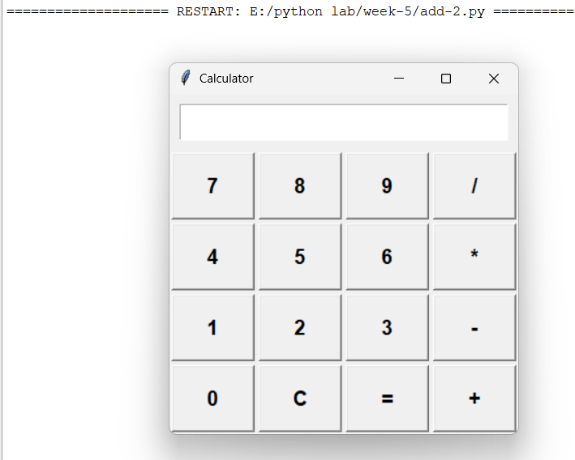
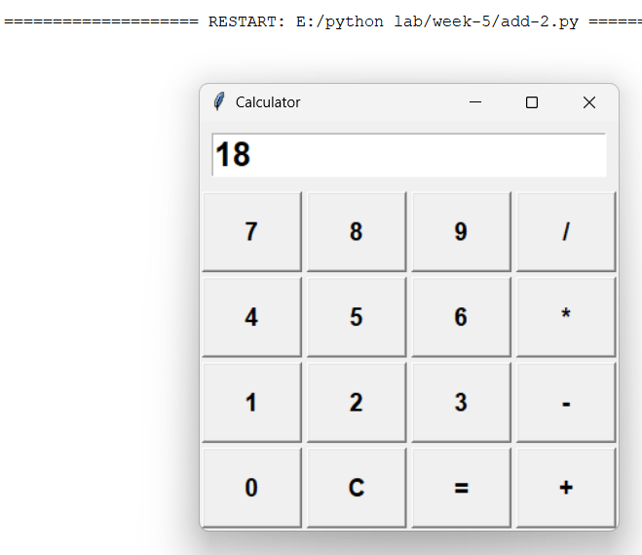
Result:
The application provides a functional GUI calculator in Python.

Add-3
Aim :
To develop a Python GUI application for managing a to-do list with add, delete, and update features.
Description :
This GUI application enables users to enter tasks, update existing ones, and delete them from a list. It uses Tkinter widgets for the interface and Listbox for display.​
- Procedure :
- Import Tkinter and create the main window.
- Add widgets: Entry for new tasks, Listbox for task list, and Buttons for add, delete, update operations.
- Define functions to add new tasks, delete selected tasks, and update current tasks.
- Use Listbox selections to identify tasks for deletion or updating.
Source Code:
import tkinter as tk
from tkinter import messagebox
def add_task():
task = entry.get()
if task:
listbox.insert(tk.END, task)
entry.delete(0, tk.END)
else:
messagebox.showwarning("Input Error", "Enter a task!")
def delete_task():
selected = listbox.curselection()
if selected
listbox.delete(selected)

else:
messagebox.showwarning("Selection Error", "Select a task to delete!")

def update_task():
selected = listbox.curselection()
if selected and entry.get():
listbox.delete(selected)
listbox.insert(selected, entry.get())
entry.delete(0, tk.END)
else:
messagebox.showwarning("Update Error", "Select a task and enter updated text!")

root = tk.Tk()
root.title("To-Do List")
entry = tk.Entry(root, width=40)
entry.pack(padx=5, pady=5)
listbox = tk.Listbox(root, width=40, height=10)
listbox.pack(padx=5, pady=5)

frame = tk.Frame(root)
frame.pack(pady=5)
add_btn = tk.Button(frame, text="Add", width=10, command=add_task)
add_btn.pack(side=tk.LEFT, padx=5)
del_btn = tk.Button(frame, text="Delete", width=10, command=delete_task)
del_btn.pack(side=tk.LEFT, padx=5)
update_btn = tk.Button(frame, text="Update", width=10, command=update_task)

update_btn.pack(side=tk.LEFT, padx=5)
root.mainloop()
output:
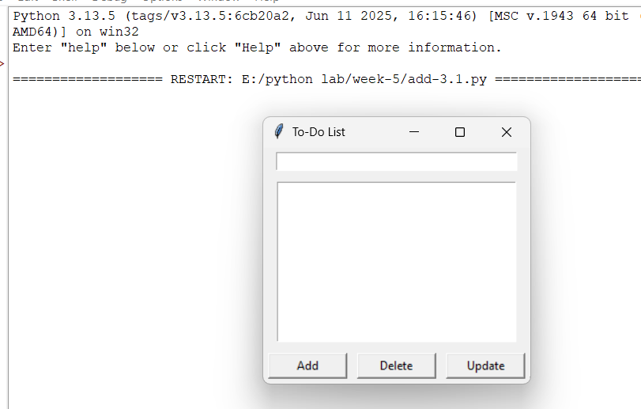
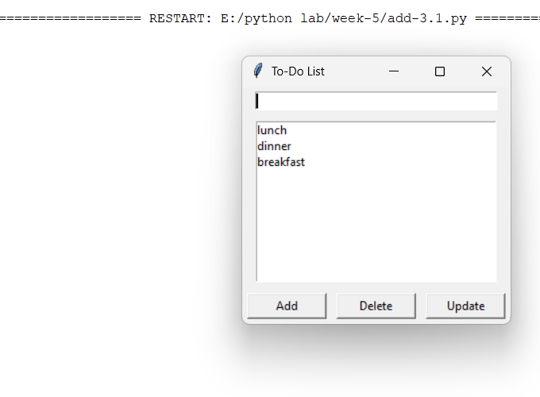
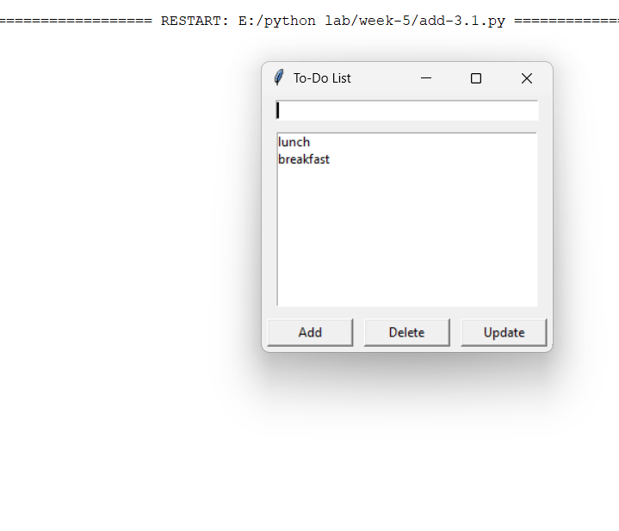
Result:
The application successfully manages a to-do list, allowing addition, deletion, and updating of tasks through a graphical interface.

